# 部署Kubernetes重要组件

此文以Kubernetes 1.18.5版本为例，且集群以kubeadm方式搭建！

## 一、部署Dashboard

下载Dashboard部署文件：

参考地址：<https://github.com/kubernetes/dashboard>

下载地址：

https://raw.githubusercontent.com/kubernetes/dashboard/v2.0.3/aio/deploy/recommended.yaml

修改镜像下载策略：

imagePullPolicy: IfNotPresent



在Master节点上部署Dashboard：

kubectl apply -f recommended.yaml

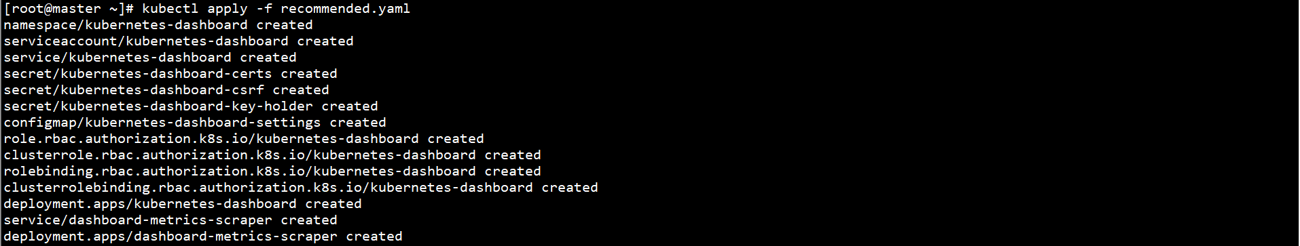

kubectl get pod -n kubernetes-dashboard



配置RBAC：

参考地址：<https://github.com/kubernetes/dashboard/blob/master/docs/user/access-control/creating-sample-user.md>

cat > serveraccount.yaml << EOF

apiVersion: v1

kind: ServiceAccount

metadata:

name: admin-user

namespace: kubernetes-dashboard

EOF



cat > clusterrolebinding.yaml << EOF

apiVersion: rbac.authorization.k8s.io/v1

kind: ClusterRoleBinding

metadata:

name: admin-user

roleRef:

apiGroup: rbac.authorization.k8s.io

kind: ClusterRole

name: cluster-admin

subjects:

- kind: ServiceAccount

name: admin-user

namespace: kubernetes-dashboard

EOF

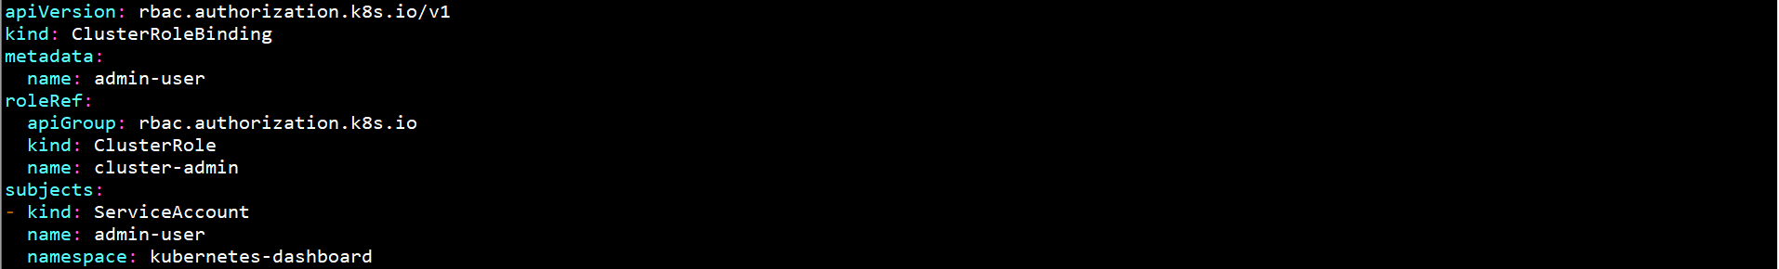

kubectl apply -f serveraccount.yaml

kubectl apply -f clusterrolebinding.yaml



修改服务类型：

kubectl patch svc kubernetes-dashboard -p '{"spec":{"type":"NodePort"}}' -n kubernetes-dashboard



或

kubectl edit svc kubernetes-dashboard -n kubernetes-dashboard

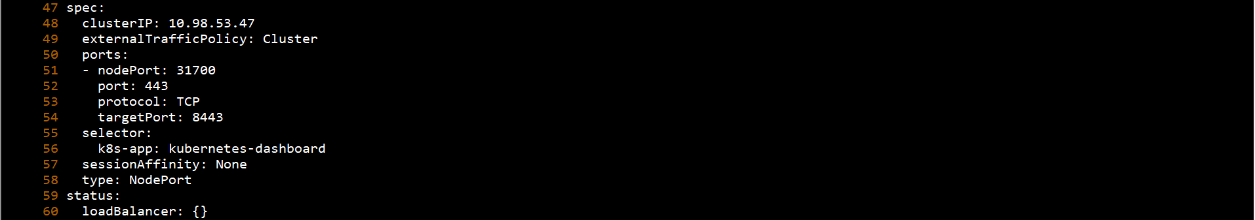

查看服务端口：

kubectl get svc -n kubernetes-dashboard



查看Token：

kubectl describe secret $(kubectl get secret -n kubernetes-dashboard | grep admin-user | awk '{print $1}') -n kubernetes-dashboard

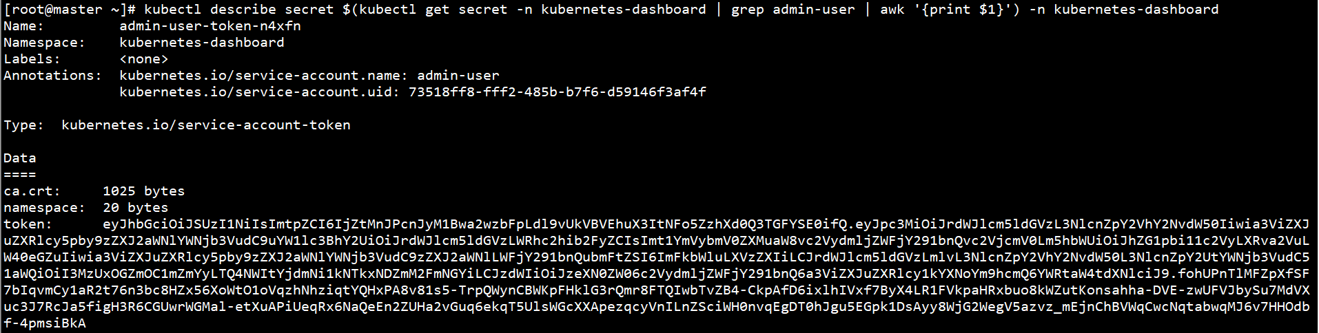

登录Dashboard：

<https://192.168.0.10:31700>

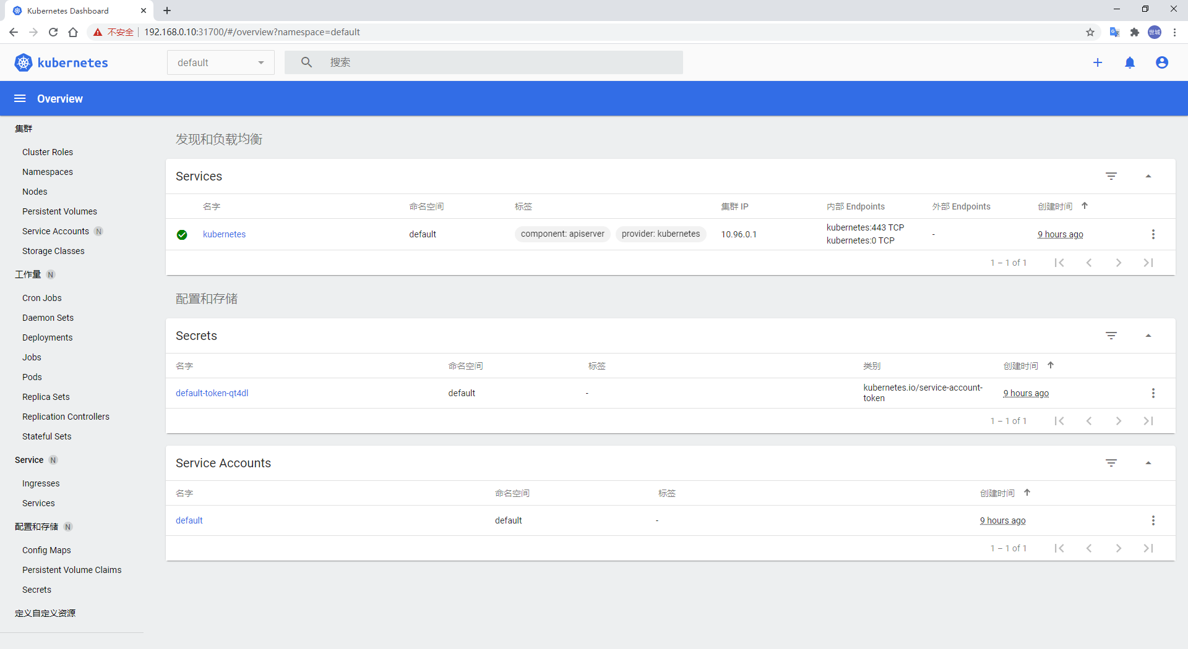

## 二、部署Metrics-Server

下载Metrics-Server部署文件：

参考地址：<https://github.com/kubernetes-sigs/metrics-server>

下载地址：

https://github.com/kubernetes-sigs/metrics-server/releases/download/v0.3.7/components.yaml

修改部署文件：

添加两个参数--kubelet-insecure-tls和--kubelet-preferred-address-types=InternalIP

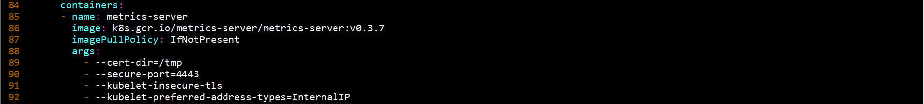

修改kube-apiserver配置文件/etc/kubernetes/manifests/kube-apiserver.yaml

添加- --enable-aggregator-routing=true

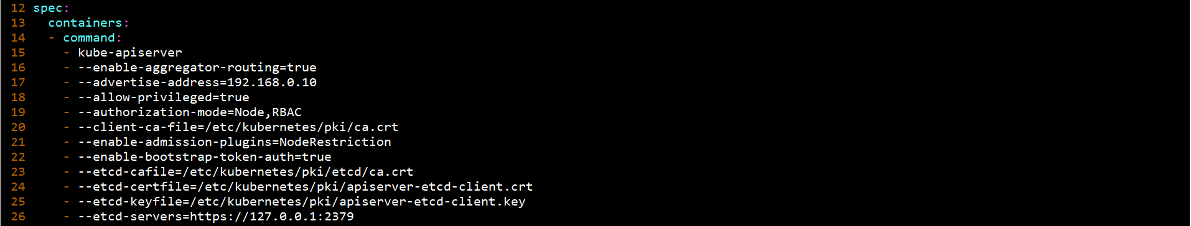

在Master节点上部署Mertics-Server：

kubectl apply -f components.yaml

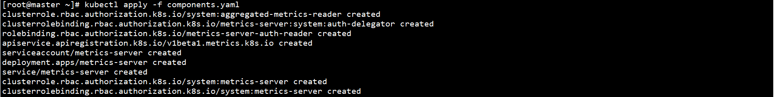

metrics-server镜像无法直接下载，Pod无法Running

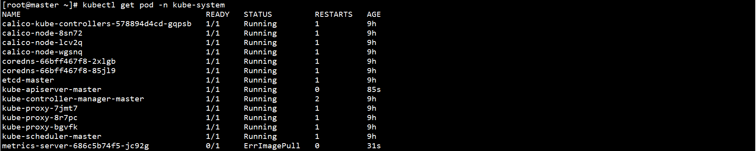

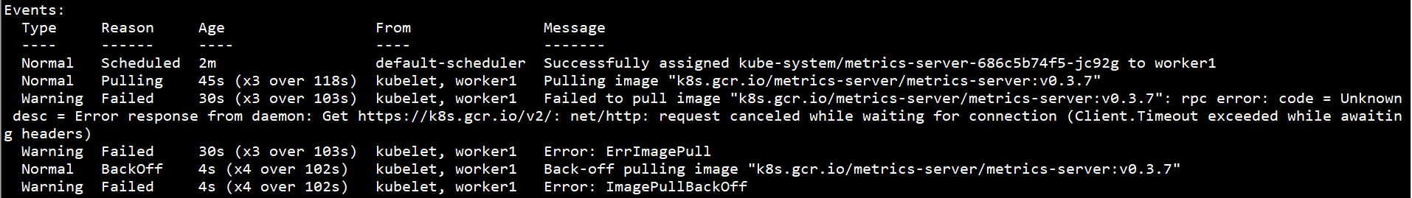

metrics-server-amd64:v0.3.7无法直接下载，需通过其他镜像仓库下载：

docker pull mengshicheng/metrics-server-amd64:v0.3.7

docker tag mengshicheng/metrics-server-amd64:v0.3.7 k8s.gcr.io/metrics-server/metrics-server:v0.3.7

docker rmi mengshicheng/metrics-server-amd64:v0.3.7

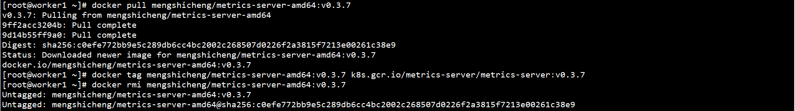

kubectl get pod -n kube-system

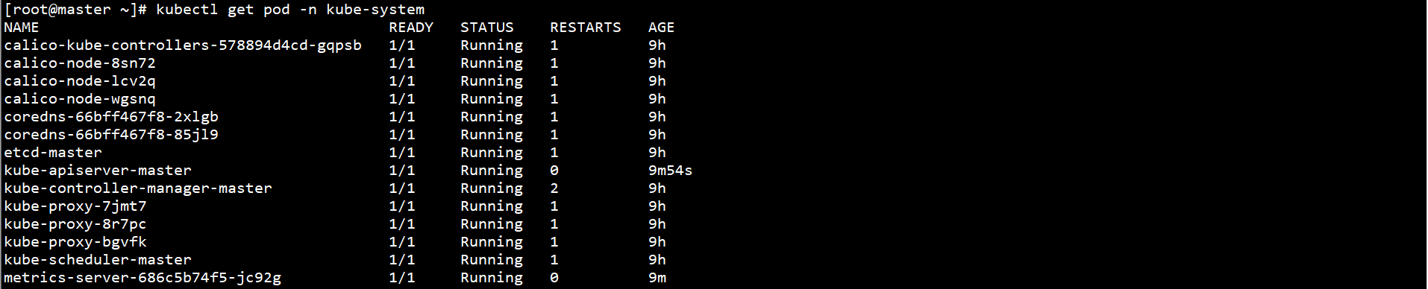

验证Metrics-Server部署生效：

kubectl top node

kubectl top pod -n kube-system

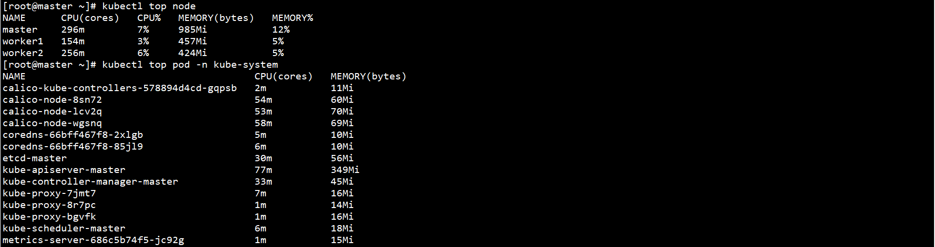

## 三、部署Prometheus

下载Promrtheus部署文件：

参考地址：<https://github.com/coreos/kube-prometheus>

下载地址：<https://github.com/coreos/kube-prometheus/tree/master/manifests>

下载Promrtheus文件：

git clone https://github.com/prometheus-operator/kube-prometheus.git

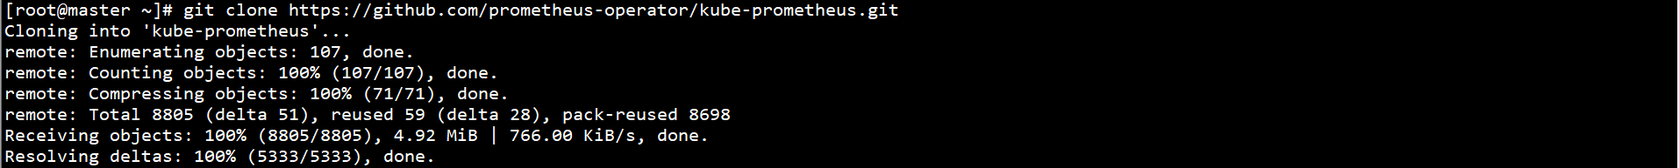

在Master节点上部署Prometheus：

kubectl apply -f kube-prometheus/manifests/setup/

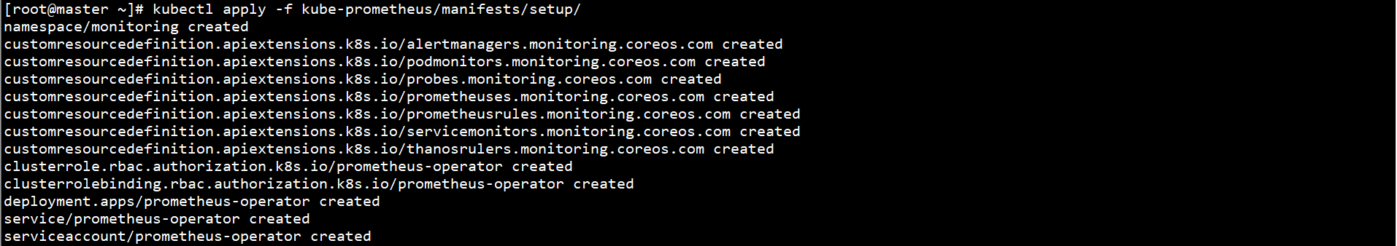

kubectl apply -f kube-prometheus/manifests/

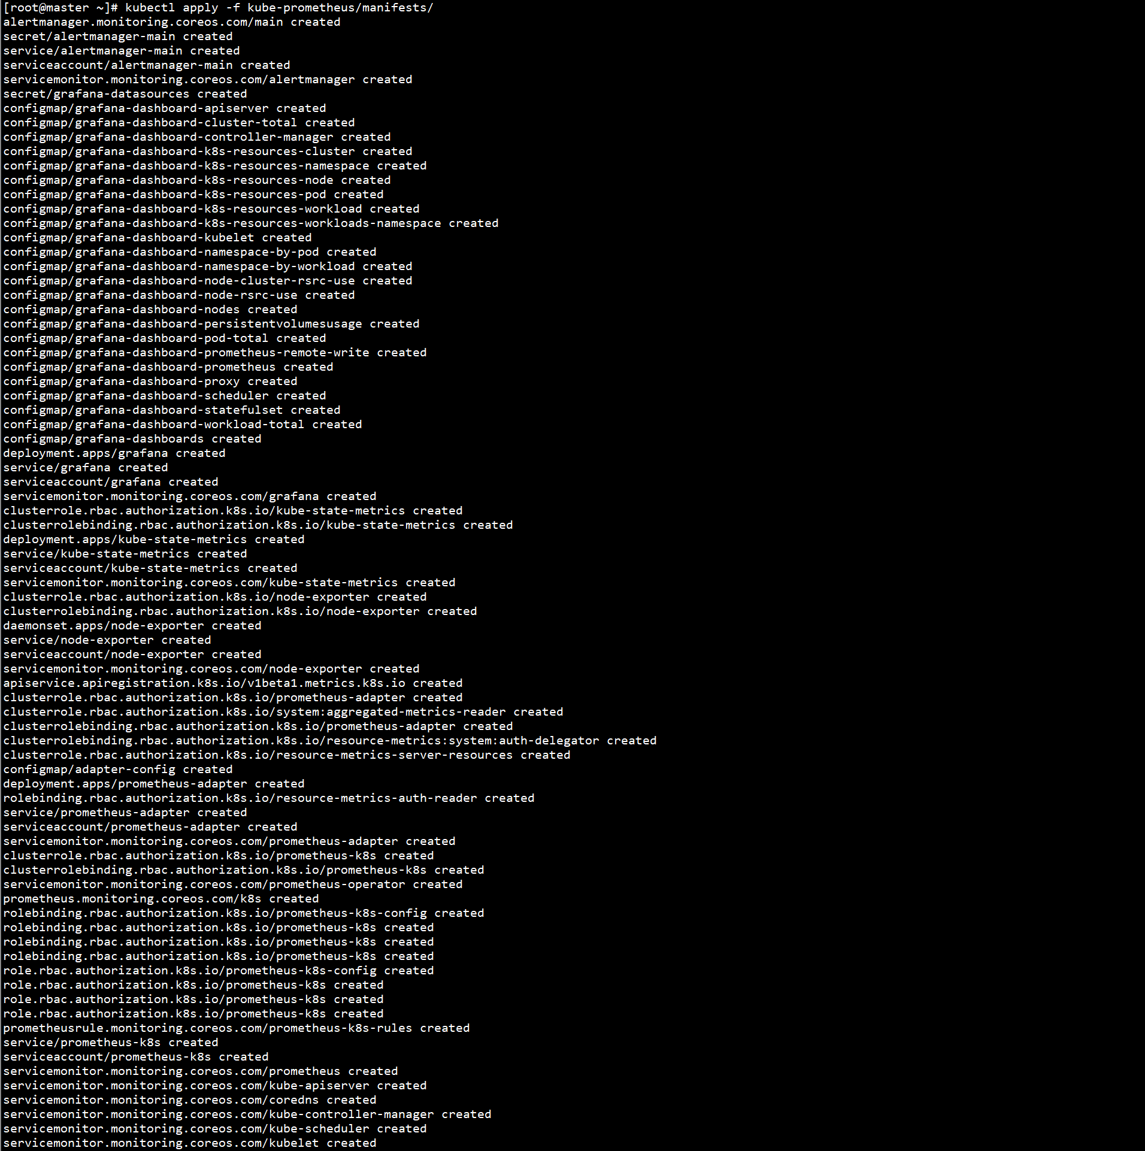

kubectl get pod -n monitoring

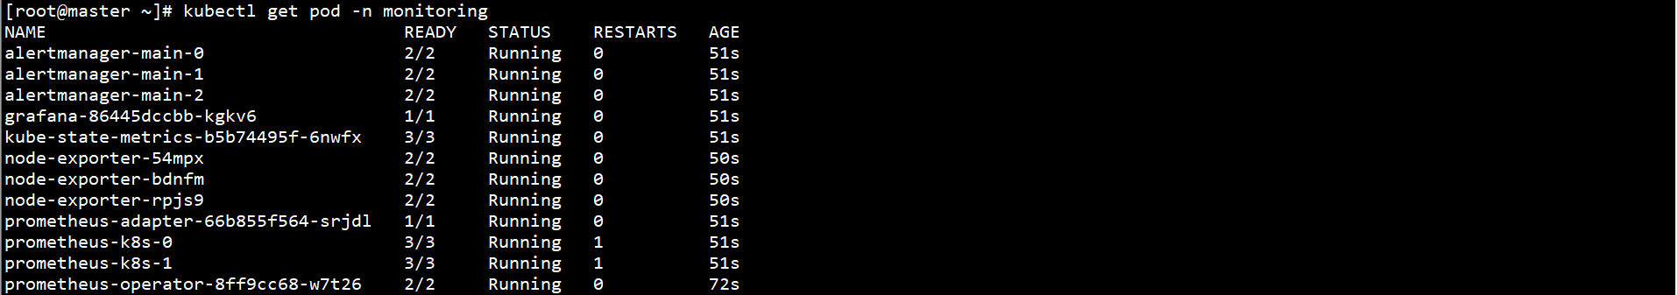

修改服务类型：

kubectl patch svc grafana -p '{"spec":{"type":"NodePort"}}' -n monitoring



或

kubectl edit svc grafana -n monitoring

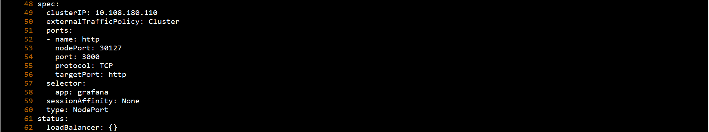

查看服务端口：

kubectl get svc grafana -n monitoring



登录Grafana：

<http://192.168.0.10:30127，默认用户名/>密码为admin/admin

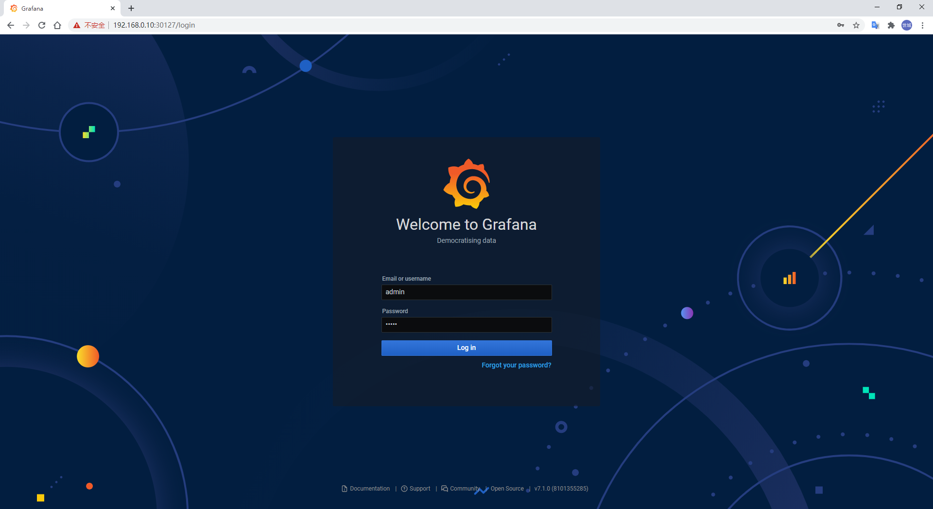

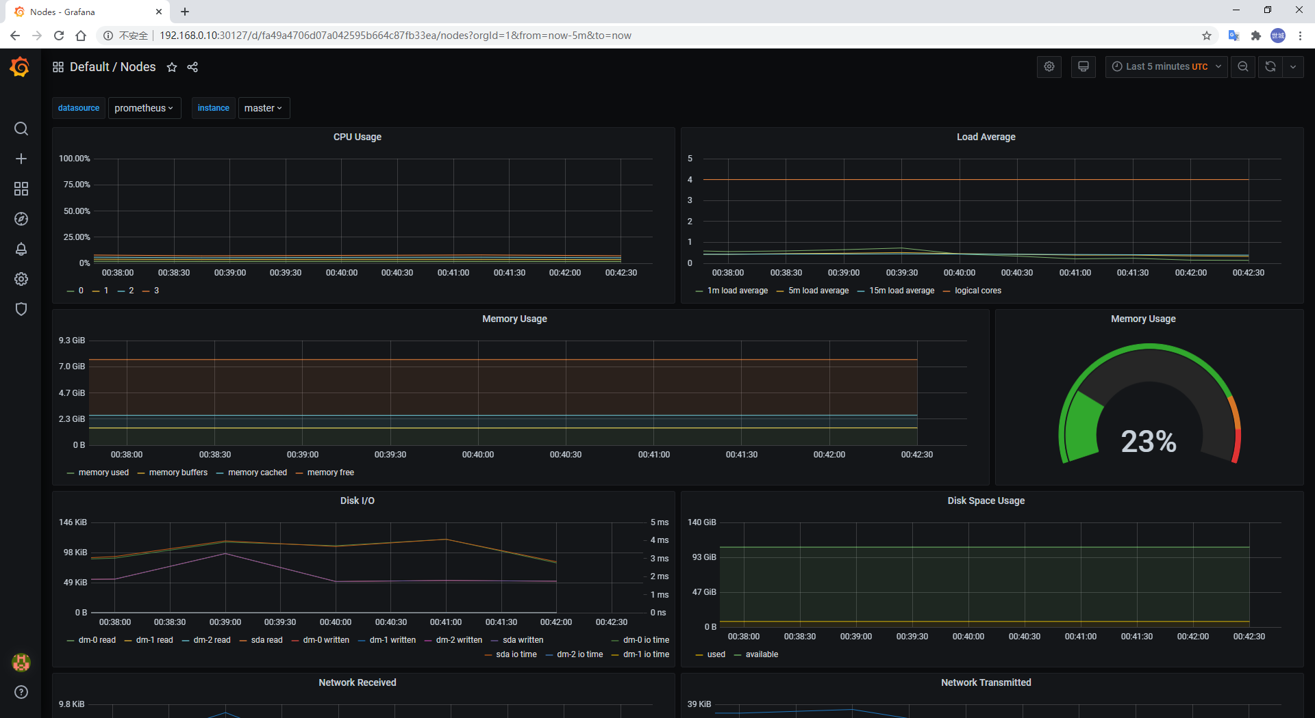

## 四、部署Helm

参考地址：<https://github.com/helm/helm>

下载地址：https://get.helm.sh/helm-v2.16.10-linux-amd64.tar.gz

在Master节点上安装helm：

tar -xf helm-v2.16.10-linux-amd64.tar.gz

mv linux-amd64/helm /usr/local/bin/helm



配置RBAC：

参考地址：<https://v2.helm.sh/docs/rbac/>

cat > helm-rbac.yaml << EOF

apiVersion: v1

kind: ServiceAccount

metadata:

name: tiller

namespace: kube-system

---

apiVersion: rbac.authorization.k8s.io/v1

kind: ClusterRoleBinding

metadata:

name: tiller

roleRef:

apiGroup: rbac.authorization.k8s.io

kind: ClusterRole

name: cluster-admin

subjects:

- kind: ServiceAccount

name: tiller

namespace: kube-system

EOF

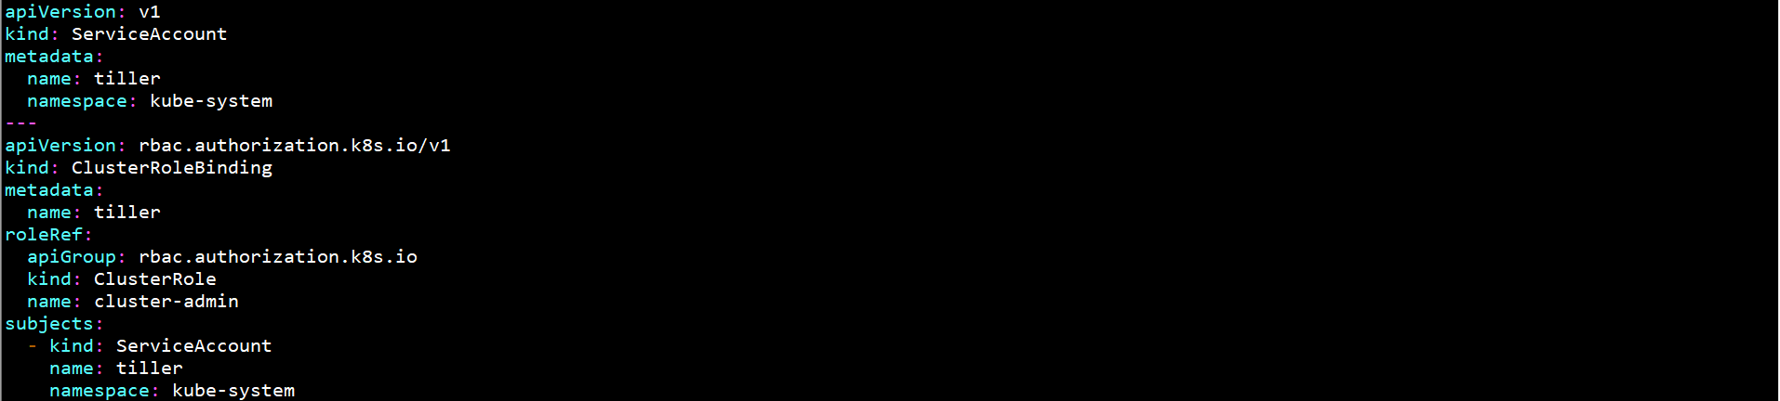

kubectl create -f helm-rbac.yaml



安装tiller：

helm init --service-account tiller --history-max 200

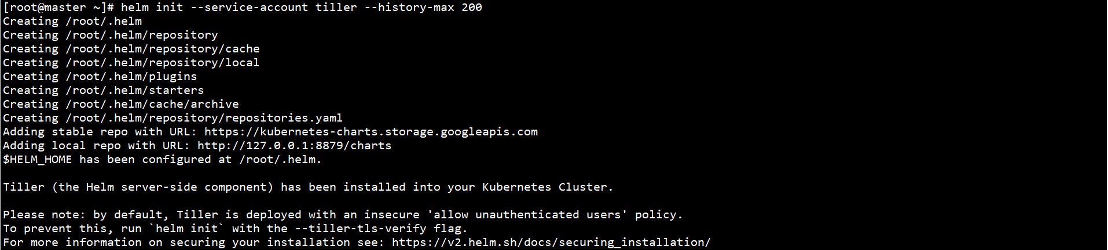

tiller镜像无法直接下载，Pod无法Running

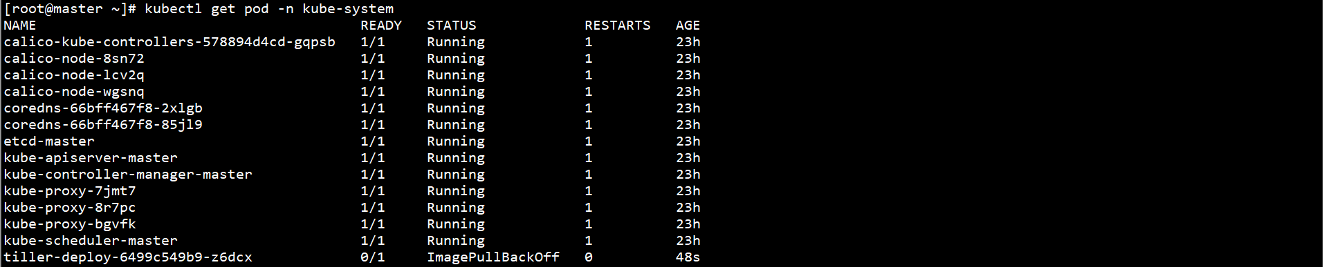

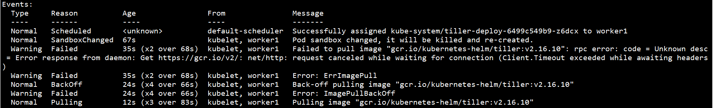

tiller:v2.16.10无法直接下载，需通过其他镜像仓库下载：

docker pull mengshicheng/tiller:v2.16.10

docker tag mengshicheng/tiller:v2.16.10 gcr.io/kubernetes-helm/tiller:v2.16.10

docker rmi mengshicheng/tiller:v2.16.10

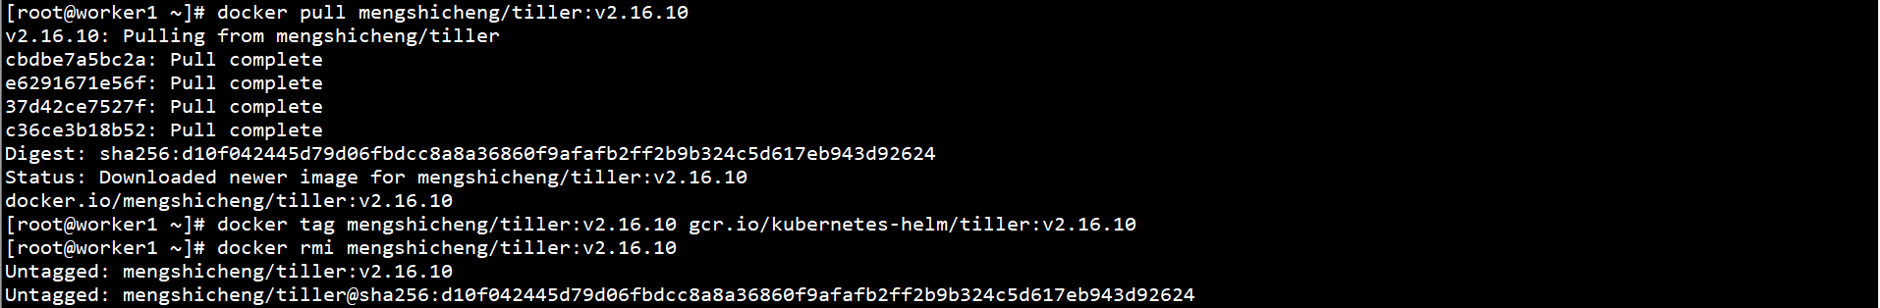

kubectl get pod -n kube-system

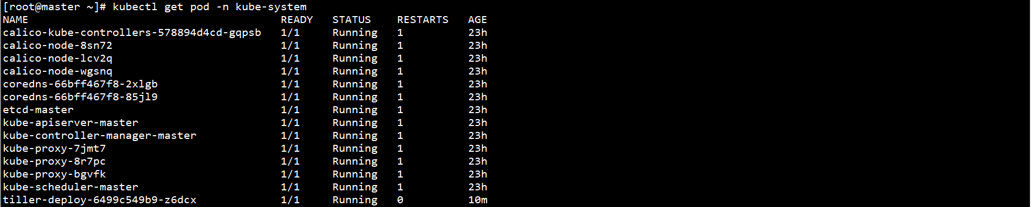

验证helm和tiller：

helm version

